Year 1 Lecture notes summary
- Growth is the sustained increase in aggregate output over time. It is how we increase or sustain our material standard of living over generations.
  - Output per person the main variable to compare welfare across time or nations
  - May also want to consider national output for geopolitical reasons

Solow-swan model
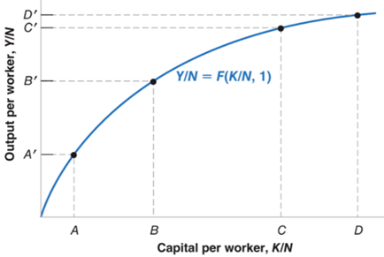
- Highlights the importance of capital accumulation and technical progress for economic growth. Aggregate production function is:$$Y=F \left(K, N\right)$$
  - We assume constant returns to scale and diminishing returns to a fixed factor.
- Can adjust this aggregate production function to account for population:
  - Y/N = F (K/N, N/N)
  - Y/N = F (K/N, 1)
  - Here, output per worker is a function of capital per worker, positively correlated but with decreasing strength

Sources of growth
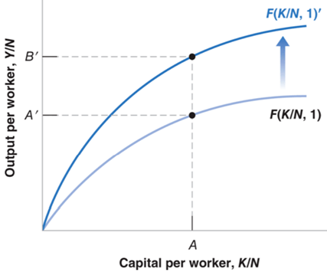
Increases in output per worker come from two sources:
- Increases in capital per worker, K/N
- Technological advancements which change A and shift the production function outwards, allowing Y/N to increase for every level of K/N.
There are two key implications of the Solow-Swan model:
- Capital accumulation cannot by itself sustain growth, as increases in K/N have diminishing returns
- Sustained growth requires sustained technological progress. Long run rate of growth of output per person is determined by technological progress, which shifts the production function outwards

Savings, capital accumulation and output
- Long run output rests on two relations between output and capital
  - Capital determines output through the aggregate production function
  - Output determines savings, and in turn the amount of capital accumulated over time. Public savings are 0 and private savings are proportional to income
    - S_{t} = sY_{t}
  - Assuming a closed economy Y = C + I + G, where → I = S + [T – G], and where public savings are 0 (I = S), we see that: I_{t} = sY_{t}

Investment and capital accumulation
- Links the flow concept of investment to the stock concept of capital. The evolution of the capital stock is given by: $K$_{t+1} $=\left(1-δ\right)K$_{t} + $I$_{t.}
  - Here, delta denotes the rate of capital depreciation.
  - Thus, for $K$_{t+1} $≥K$_{t}, the rate of depreciation as a proportion of $K$_{t} must be less than $I$_{t} as a proportion of $K$_{t}.
- We can express the evolution of the capital stock per capita, and substituting the private savings rate in for the rate of investment:
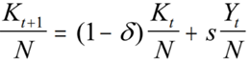

  - This means that the capital stock in year t+1 is equal to the current capital stock that is still intact, plus savings, which translate into investment in new capital stock

Part II Reading

Long run model of production (4.1-4.3)
- Key assumptions of a single, closed economy with a composite good. Fixed amount of labour and capital.
  - L bar notates labour
  - K bar notates capital
  - The bar denotes parameters which are fixed constants exogenously given in the model

- We use a production function to show much output Y bar can be produced if L workers are combined with K capital.
  - A bar is a positive constant referred to as the productivity parameter
  - Productivity parameter assumed to be constant, but K and L can vary
  - This is a Cobb-Douglas function exhibiting constant returns to scale as the powers sum to 1. This assumption is justified through the standard replication argument

Allocating resources
- Profit maximising firm seeks to maximise this function minus the rental price of capital and wage cost of labour.
  - To do so, the firm should hire capital until the MPK is equal to the rental price r, and hire labour until the MPL equals the wage w
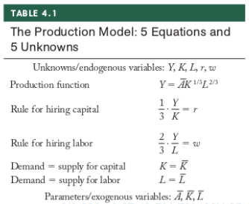
- The marginal product of labour is proportional to the average amount each worker produces (Y/L), where this factor of proportionality is the Cobb-Douglas exponent (2/3). At the profit maximising point, MPK = r and MPL = w, or:
  - MPK = 1/3 x Y/K = r
  - MPL = 2/3 x Y/L = w

General equilibrium
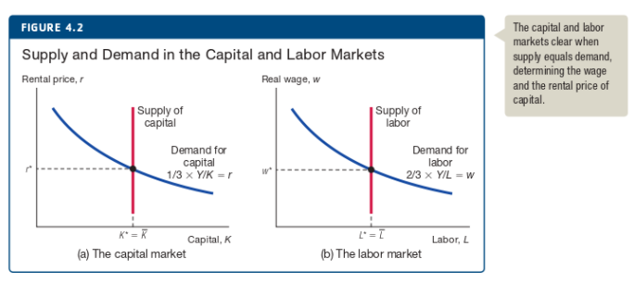
- 5 exogenous variables in the model, 3 quantities (Y, K and L) and two prices (w and r).

Analysing the production model
- Solving the model for output per person accounts for population discrepancies. Output per person in equilibrium is the product of the productivity parameter A bar and capital per person, k bar.
  - So output per person is positively correlated to productivity and capital per person
  - Increasing capital per person increases output per person at a diminishing rate
